Facebook Status’
*Don’t post early in the morning (7:20 AM only got 14 views)
Sunday at 7:40 and 7:50PM did very well
Monday at 7:20PM was pretty well
Wednesday at 8:30PM did well
Tuesday at 1:30 PM did not work well, 7:30 PM did okay, and at 8pm did not get many views, but got a good response
Thursday 7:10PM did okay
Friday at 3:13 PM worked very well and another one not so well! At 7:50PM didn’t do very well

Approved
11/8/13- Remington Shotgun post
11/9/13- “The nation which forgets its defenders will be itself forgotten.” ~ Calvin Coolidge
11/11/13 – Today is the birthdate of General George S. Patton! Here is our George S. Patton Tribute Pistol on a Colt .45 pistol: http://www.americaremembers.com/Products/GGSPJTP/GGSPJTP.asp
11/11/13 - Thank you to all of our Veterans who so bravely fought to preserve our cherished American freedoms. Happy Veterans Day! This is the 75th Anniversary of Veterans Day since the signing of Public law 510 on May 13, 1938, which officially established Veterans Day as a legal national holiday. http://www.americaremembers.com/product/tribute-to-americas-armed-forces-thompson/ 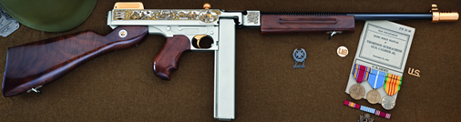
11/13/13 – It is reported that approximately two percent of the United States population died in the Civil War (more than 620,000—died in it). http://www.pbs.org/civilwar/war/facts.html
11/15/13- “My artistic approach is not to do a historical document, but more a portrayal of a scene that has happened many times in many places in the West. I want to give that scene as much visual impact as possible, so the detail and action are as accurate as I can make them.” -Frank McCarthy… We have a few Tributes featuring the artwork by the legendary Western artist Frank McCarthy. Here is our Frank McCarthy U.S. Calvary Tribute Revolver: http://www.americaremembers.com/product/the-frank-mccarthy-u-s-calvary-tribute-revolver/ (ADD PICTURE)
11/17/13- Recently, one of our customers emailed us this nice note, “I took delivery of my Civil War Henry Repeating Rifle yesterday. Wowww, what a beauty! Thank you for a great masterpiece!” http://www.americaremembers.com/product/the-civil-war-sesquicentennial-tribute-rifle/ 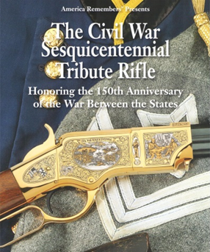
11/19/13- On this day in 1863, Lincoln gave the Gettysburg Address reminding the public of the principles of human equality in the Declaration of Independence.
11/20/13 - “The Battle of Little Big Horn also known as Custer's Last Stand took place on June 25, 1876. Lieutenant Colonel Custer's forces—including more than 200 of his men were wiped out in less than 20 minutes.” http://www.legendsofamerica.com/we-facts4.html
11/22/13- Clint Walker is one of our favorite cowboys from the golden age of Westerns. The complete Season 6 of “Cheyenne” is available on DVD for Clint Walker. Get your personally autographed copy from Clint walker for $47.95. Visit www.ClintWalker.com to order. Make sure you also checkout our Clint Walker Tribute Rifle here: http://www.americaremembers.com/product/clint-walker-tribute-rifle/ 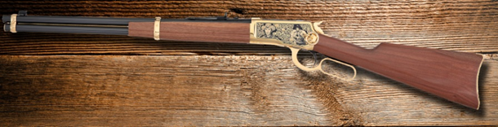
11/24/13- “Where liberty dwells, there is my country.” – Benjamin Franklin
11/26/13- It’s reported, cowboys during the Old West would sing to their cattle because it “soothed jittery cows, which helped reduce the likelihood of stampede.” http://thewildwest.org/cowboys/wildwestsongsandpoems.html
11/28/13 – President Abe Lincoln was the one who declared the last Thursday of November would be Thanksgiving Day. We hope everyone has a Happy Thanksgiving!!! Don’t forget to count your blessings!
12/1/13- “…the right of the people to keep and bear Arms, shall not be infringed.” Checkout our th NEW National Rifle Association Tribute Shotgun honoring the NRA’s patriotic commitment as “Defenders of Freedom”.
12/2/13- “Wars may be fought with weapons, but they are won by men.” – General George S. Patton, Jr. Checkout our General George S. Patton, Jr. Tribute Revolver: http://www.americaremembers.com/product/general-george-patton-revolver/ (INSERT BROCHURE COVER)
12/4/13 - “Theodore Roosevelt was sent to live in North Dakota for health reasons. He fell in love with the West and wrote a book titled "Ranch Life and the Hunting Trail" before becoming a US president. The book was illustrated by famous Western artist Frederic Remington.” http://www.legendsofamerica.com/we-facts3.html http://media.nara.gov/media/images/38/3/38-0265a.gif
12/7/13 – Today is National Pearl Harbor Remembrance Day when we remember those who died in the Pearl Harbor Attack in 1941.
12/9/13- It is reported, “Confederate General Nathan Bedford Forrest had 30 horses shot from under him and personally killed 31 men in hand-to-hand combat. ‘I was a horse ahead at the end,’ he said.” http://www.pbs.org/civilwar/war/facts.html
12/11/13- The life expectancy in the United States in 1900 was 47 years old! Thankfully it is much higher than that today! http://demog.berkeley.edu/~andrew/1918/figure2.html
12/13/13- Kind words from one of our loyal customers, “The Museum of the Confederacy is without a doubt the finest black powder revolver offered in the past. It is the best yet and words cannot describe it.” http://www.americaremembers.com/product/the-museum-of-the-confederacy-tribute-revolver/
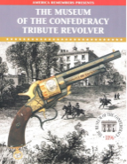
12/16/13- The Boston Tea Party was today in 1773 in Boston.
12/18/13- Did you know the battle of Gettysburg had approximately 50,000 casualties including the wounded and killed?!? To honor all those who served and died at Gettysburg, checkout our Mort Kunstler Gettysburg Tribute Rifle which features artwork from the legendary Civil War artist acclaimed for his research and accurate portrayals! http://www.americaremembers.com/products/MKGTRI/MKGTRI.asp 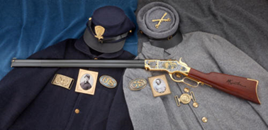
1/1/14- Happy New Year’s Day!
1/7/14- On this day in 1789, the United States’ first presidential election was held. George Washington won the election.
1/8/14- Happy Birthday to the one and only Elvis Presley! Check out our Elvis Presley Tribute Revolver! http://www.americaremembers.com/product/elvis-presley-tribute-revolver/ (INSERT BROCHURE COVER PICTURE)
1/11/14- “On January 11, 1908, U.S. President Theodore Roosevelt declares the massive Grand Canyon in northwestern Arizona a national monument.” http://www.history.com/this-day-in-history/theodore-roosevelt-makes-grand-canyon-a-national-monument
1/13/14- “I just received my Centennial Anniversary 1911. I just wanted to say thank you. My experience with your staff has been great from the start. They are very courteous and helpful over the phone. I would also like to say that the firearm exceeded my expectations in quality and workmanship. The pictures don’t do it any justice in showing how truly beautiful it is.” –Email from one of our happy customers http://www.americaremembers.com/product/the-colt-centennial-anniversary-tribute-pistol/
Not Approved but checked the facts
1/17/14- Today is Benjamin Franklin’s birthday! Anyone else think he was a pretty cool guy?
1/19/14- Robert E. Lee’s birthday is today! Check out our Robert E. Lee Tribute Revolver! http://www.americaremembers.com/product/robert-e-lee-tribute-revolver/ (INSERT BROCHURE COVER PICTURE)
December 25-
Don’t Forget
May 26, 2014 – Memorial Day
June 6, 2014 – D-day
June 14, 2014 – Flag Day
July 4th, 2014 – Independence Day
September 11, 2014 – Patriot Day
September 17, 2014 – Constitution Day
November 11, 2014 – Veterans Day
November 27, 2014 - Thanksgiving Day
December 7, 2014 - Pearl Harbor
December 25, 2014 -Christmas day

Look at Celebrity birthdays excel spreadsheet

http://research.archives.gov/

